For this homework assignment, we are analyzing a bunch of data that has been collected by the Allen Institute. To start, we import all our required tools and connect to the Allen Institute Database (not my code).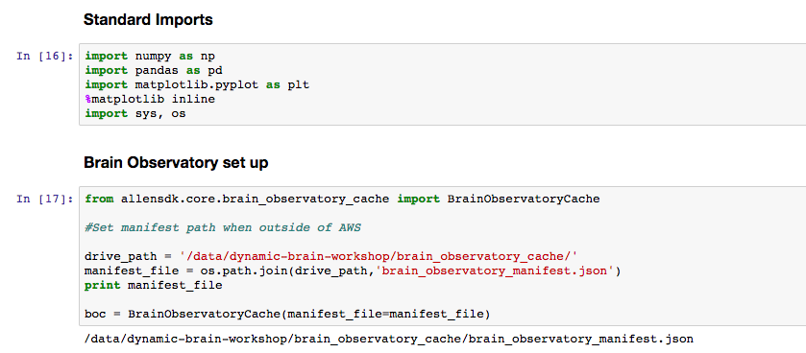

Next, we define a function for extracting the response of a single cell to a set of stimuli from this database. This returns a stimulus table which shows which stimuli were presented during specific frames of the trial, and all the response information is stored in dff_trace (not my code). Throughout a given trial, stimulus values that vary in orientation and temporal frequency are presented in a random series.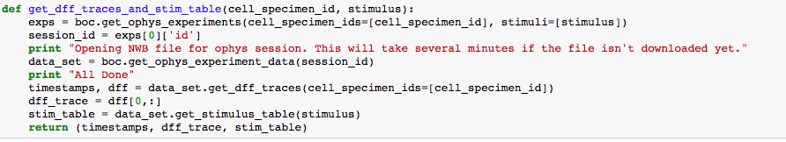

In order to analyze this data, I define a function for extracting the responses from dff_trace to a specific set of stimuli. To do this, I first extract all the possible orientation and temporal frequency values from my stimulus table (the first for loop) and then organize these into a sorted list, removing all duplicates. In the next block of code, for each stimulus (for each orientation value and each temporal frequency value) I search for all the trials within my given dataset that had this same stimulus, and average the cell’s response across all these trials to get a single metric for the response to this given stimulus. Additionally, I calculate the standard deviation to get an idea for how the cell’s response varies trial to trial. Lastly, I plot these means and standard deviations within a tuning curve, one curve for orientation and one for temporal frequency, in order to get a visual of the types of stimuli the cell is responding to.

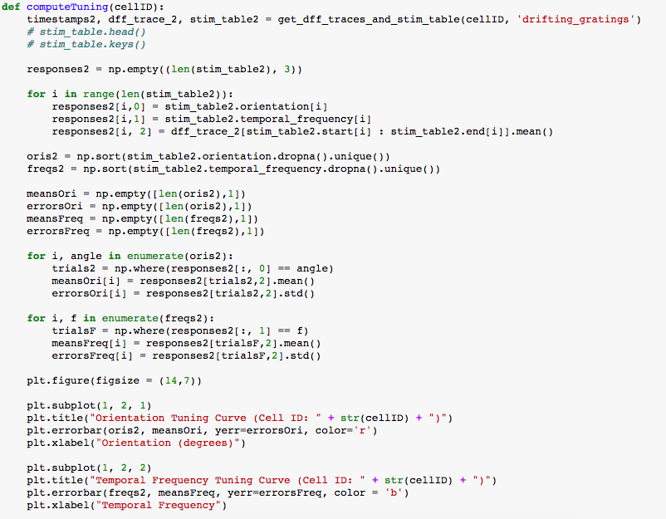

Once I have my function defined, I analyze the responses of several cells to the same range of stimuli in order to get a picture of how the response varies cell to cell.

forLoop.png

This first cell seems most responsive to orientations around 90 or 270 degrees, with little activity elsewhere. Additionally, it seems to prefer lower temporal frequencies, but this metric does not seem to have as large as an overall impact as the orientation.

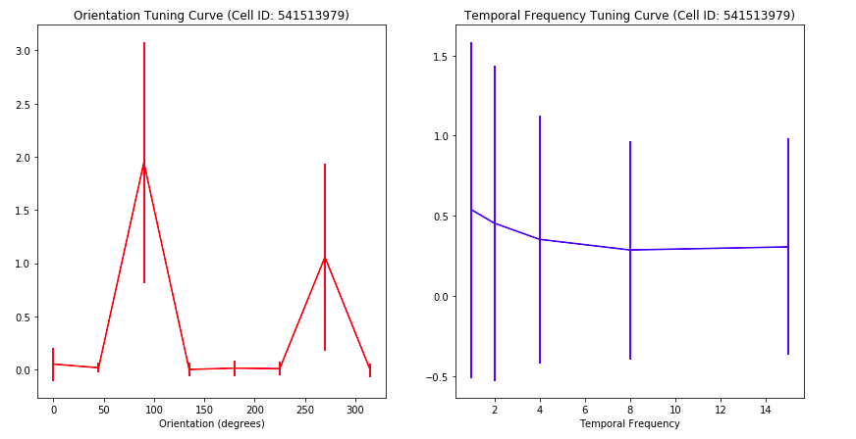

This next cell seems to prefer low orientation and temporal frequency values, but its overall reaction to any stimuli is much lower than we saw in the previous cell. Maybe this cell is not “looking” for these specific features in an image, but rather other qualities.

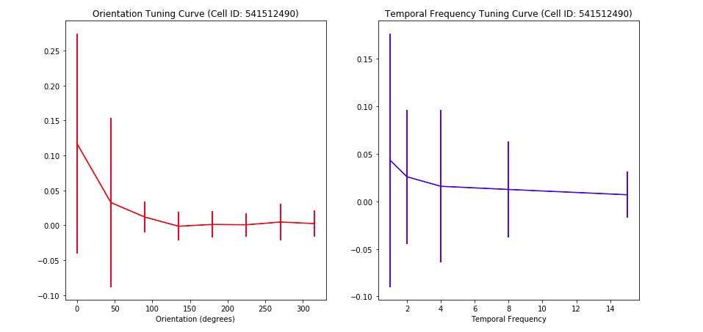

Both these cells seem to be reacting to similar stimuli, orientations around 90 or 270 degrees and a higher temporal frequency. It seems there is some consistency cell to cell in what qualifies as a preferred stimulus, in that each cell is not looking for completely different aspects of an image.

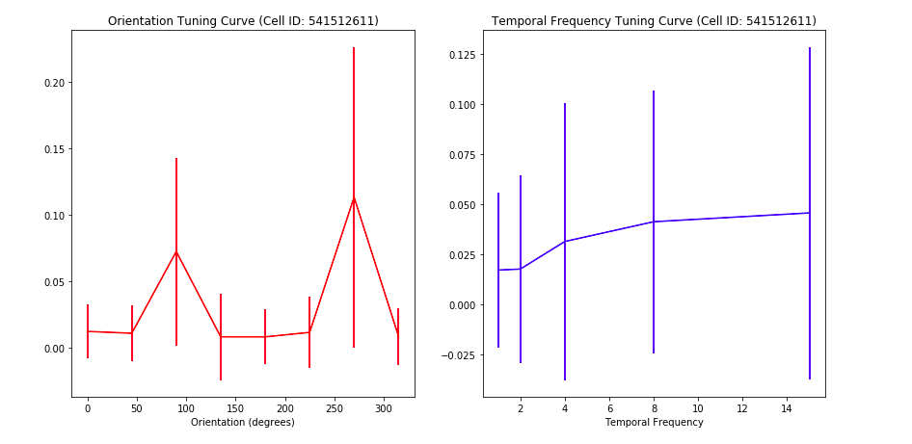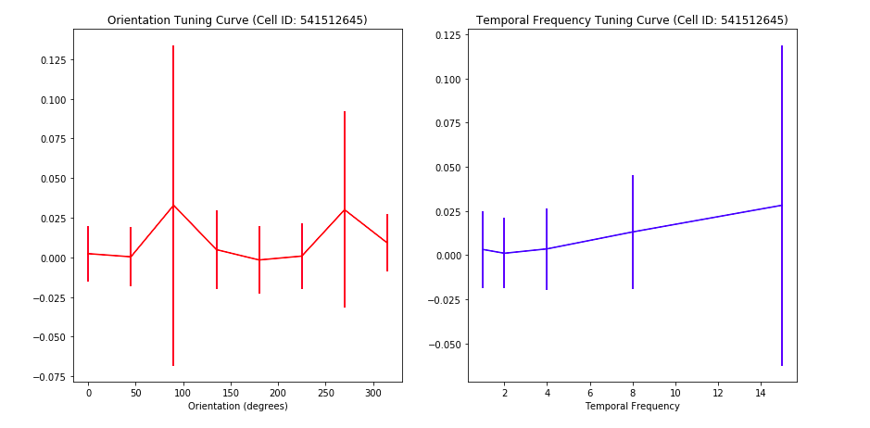

While the first cell seems to show little significant activity, the second cell seems to favor an angle close to 0 and, more interestingly, a value close to 180 degrees, behavior none of the previous cells has exhibited. Additionally, this second cell appears to favor higher temporal frequencies, just like the previous cells.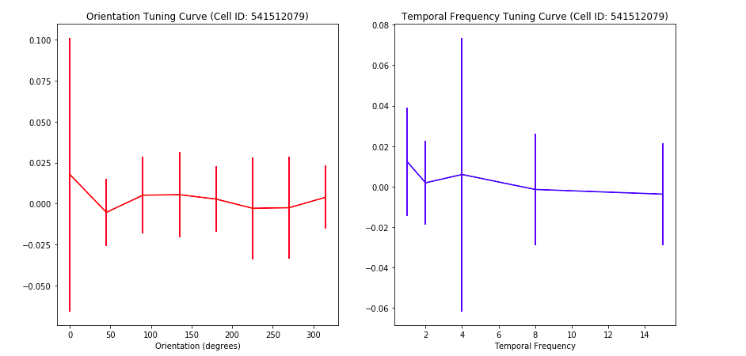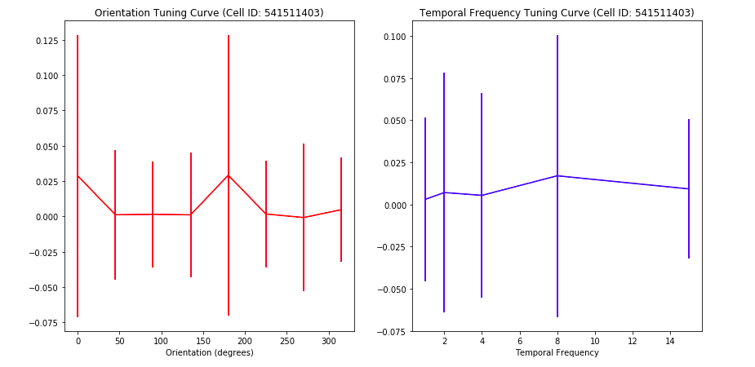

For the first cell, we see it reacts almost exclusively to an orientation of 180 degrees. However, it seems the cell does not react practically at all to the temporal frequency.

The second cell seems to prefer an orientation around 90 degrees, but again does not react much to the temporal frequency.

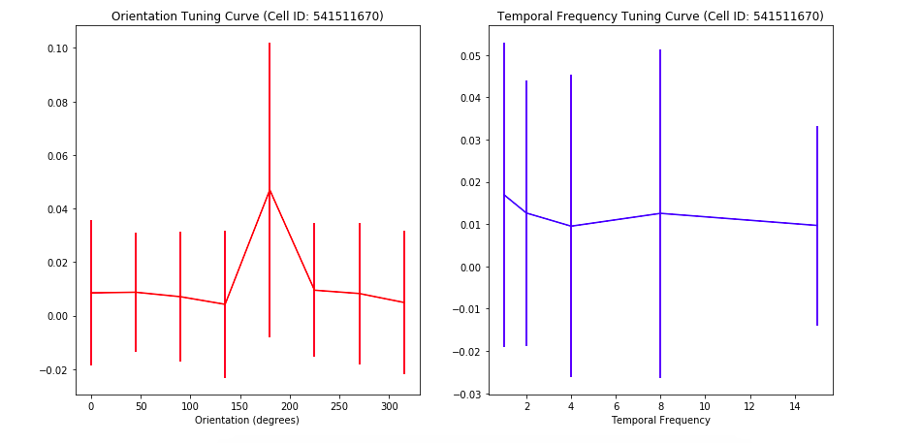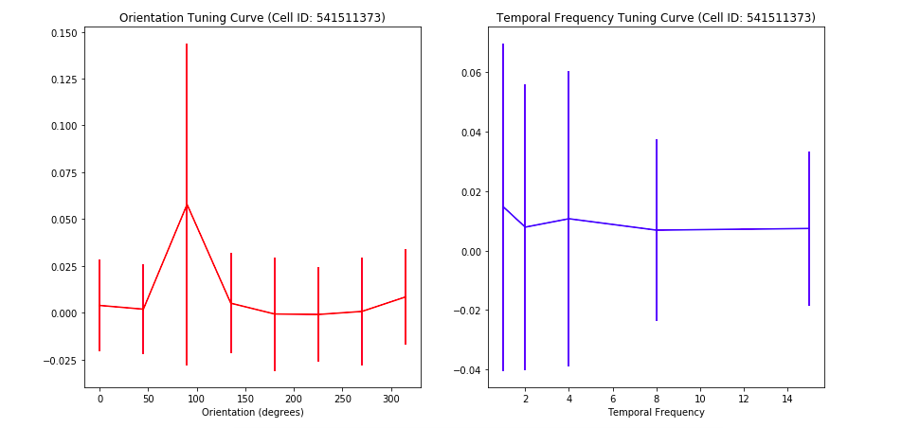

The first cell seems to prefer an orientation of around 90 degrees, and prefers lower frequency values. The second cell seems to react to many different orientations (0,90,180, and 270) and again prefers lower frequencies.

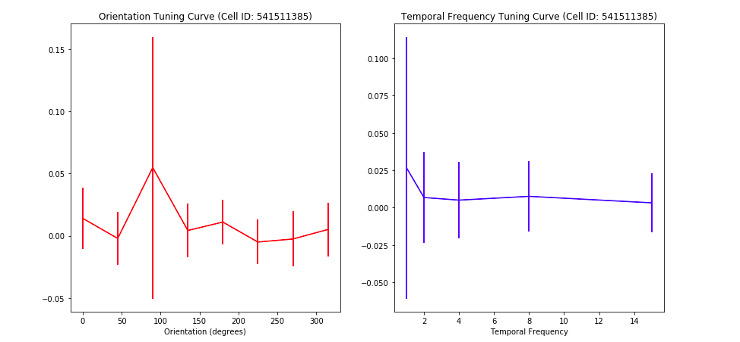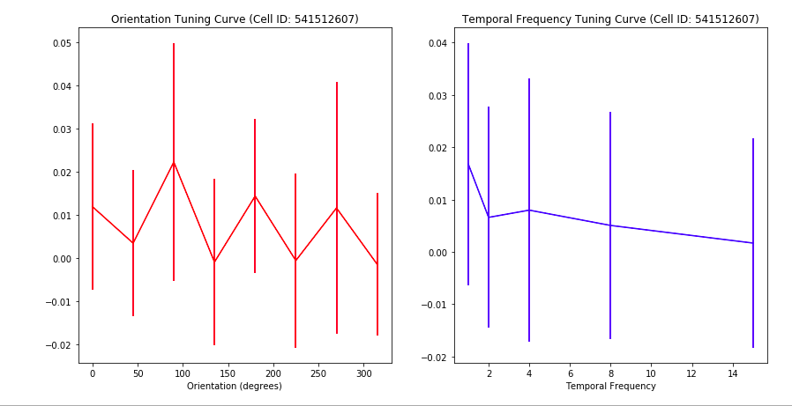

**Q: In what ways do these tuning curves differ? In what ways are they the same? What are interesting parameters of a cell’s response to this stimulus?**

Looking at the above tuning curves, I noticed the preference for temporal frequency was fairly binary in all cells. Cells seemed to either prefer lower frequencies or higher frequencies, with a slight slope between the two. Unlike with the orientation, there was no specific temporal frequency that created a large response in any of the cells. In this sense, these cells are not “looking” for specific temporal frequencies, but rather it seems a higher temporal frequency amplifies the response in some cells, while a lower temporal frequency amplifies the response in other cells. This explains what we saw in class when we plotted the response to orientation, holding the temporal frequency constant for each plot. The preferred orientation values do not change, but different temporal frequencies amplify the response more than others, leading to higher peaks.

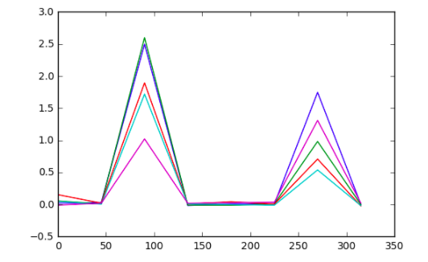

The response to varying temporal frequency typically had a lower magnitude response than the response to varying orientations, suggesting orientation is the more influential parameter.

Orientation, on the other hand, had much more variation cell to cell. Some cells responded to a single orientation, while others reacted to a wide range. This suggests orientation is a more cell-specific parameter, while temporal frequency is a more generic cell response.

However, all parameters seem to have significant variation trial to trial, leading to relatively large standard deviations. As we discussed in class, this is likely due to the fact that other parameters are varying trial to trial that may have a significant influence on the cell’s response to the stimuli. This makes it difficult to determine what the baseline response to a stimulus like orientation is, because we do not know what combination of other stimuli parameters to choose as “normal”.